**Objective Questions**:

1. What is the total no. of attributes present in the data?
2. Which columns have inconsistent or missing values, and what is the count of such values?
3. What is the average daily ticket volume over time?
4. What is the distribution of ticket categories (e.g., Login Access, System, Software)?
5. How many tickets has each agent handled?
6. How can you extract the domain from the email addresses in the IT Agents sheet?
7. How can you find the full name of an agent given their Agent ID?
8. What is the count of each issue type (e.g., IT Error, IT Request)?
9. What is the daily average resolution time for tickets?
10. How has the volume of tickets changed over time?
11. What is the average age of the IT agents?
12. Is there a correlation between the severity of issues and the resolution time?
13. How many categorical columns are there in the data? [Search about categorical and continuous data, and try to answer this question]

**Subjective Question:**

1. If there is an investment, should it be used to hire more IT agents, improve training programs, or upgrade ticket management software?

Analysis: Perform a cost-benefit analysis using ticket resolution and satisfaction metrics.

1. Which agents need additional training based on their performance metrics?

Analysis: Identify agents with the lowest satisfaction ratings and longest resolution times.

1. Do certain categories of requests have longer resolution times?

Analysis: Analyse the resolution times by request category.

1. How effective are the current software tools in managing IT tickets?

Analysis: Evaluate performance metrics before and after the implementation of new tools.

1. How has the performance of the IT support team changed over time (e.g., monthly or quarterly)?

Analysis: Trend analysis using time series charts.

1. If we invest more on tech (Hardware, software, etc), do you think it will improve the ticket resolution times and employee satisfaction?

Analysis: Use historical data to project potential improvements.

1. What are the key performance metrics for IT agents, and how can they be improved, do we need to fire any agents?

Analysis: Define and analyze metrics such as average handling time, satisfaction scores, and number of tickets resolved.

1. How do employee demographics (e.g., department, seniority) impact satisfaction and ticket outcomes?

Analysis: Segment analysis using filters and pivot tables.

1. Identify the trends for IT support operations based on ticket volumes and satisfaction, and mention the peak and stable times?

Analysis: Use pivot tables and charts to identify peak and off-peak hours.

1. What metrics should be included in the final dashboard to provide a comprehensive view of call center performance and guide investment decisions?

Answers:

Objective Questions:



There are 10 attributes in Tickets Worksheet and 5 in IT agents Worksheet.



There are no missing data but having one spelling mistake: Major is written as Mayor in Severity Column of Tickets Worksheet.

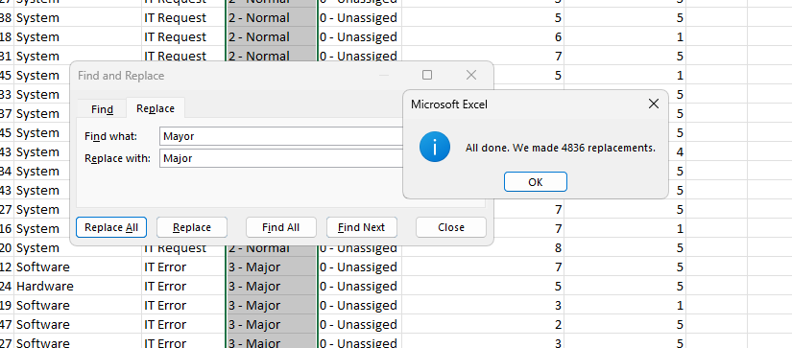



Average Daily tickets can be check by using average formula which is

=COUNTA(Tickets[ID Ticket])/ROWS(UNIQUE(Tickets[Fecha]))

=53.36

1. Below is the distribution of tickets as per request categories:

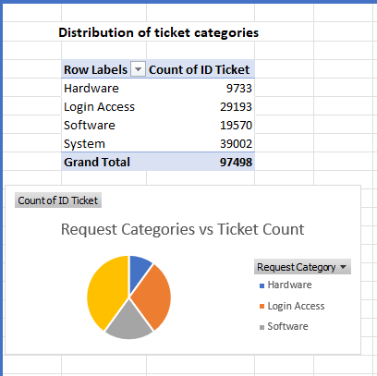



The no of tickets per agent can be fin out by the following pivot table also here is the graphical representation of the count of tickets per agent:

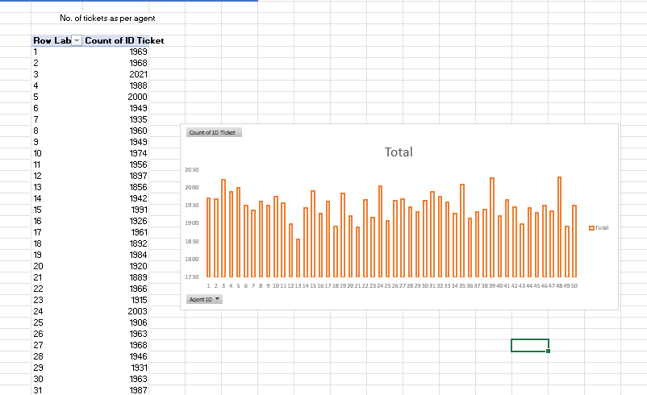

To extract domain from the email address we can do this:

=Mid([@Email],Find(“@”,[@Email])+1,13)

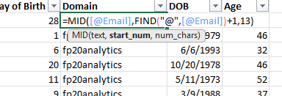

The Full name of each agent can be extracted by using the vlookup/xlookup function. I have extracted them by using xlookup function in Tickets worksheet using their AgentID, below is a snapshot of the implantation: =XLOOKUP(D2,IT_Agents[Agent ID],IT_Agents[Full Name])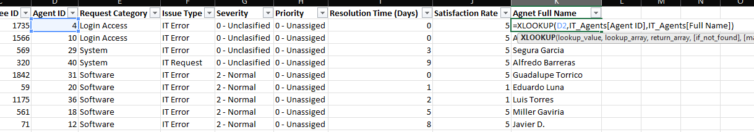



The count of tickets of each issue type is given by the below pivot table:

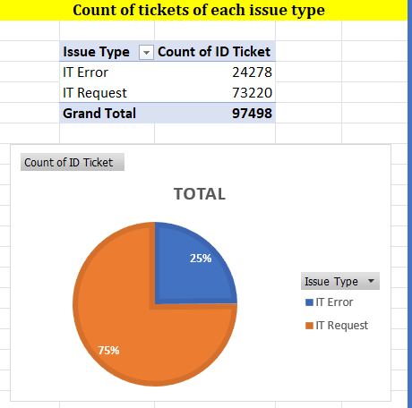

The daily Average resolution time can be found by the help of pivot table here I Grouped the date in year, months and quarters as well and expanded form of the pivot table is given below as a snapshot of the part of pivot table:

**Average resolution Time (Daily) = 4.100648218**

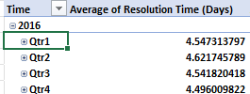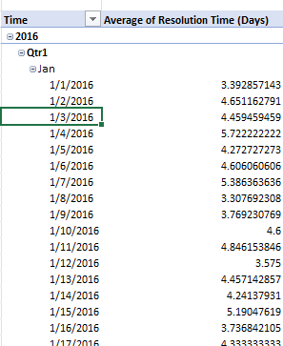



Volume of tickets are increasing yearly as shown in below table and chart:

Also below is trend of quarterly trend of tickets:



Average Age of IT agents can find by:

First Find DOB of each agent

Then find the age of each agent using Datedif function

Then create a pivot table or also can be find by average function but I used the pivot table for the same and **average age is : 40.12**



Correlation between Satisfactory rate and Resolution time is:

For this I have firstly used Text-to-column to separate the numerical and text value in severity column

=CORREL(Tickets[Resolution Time (Days)],Tickets[Num-Severity])

As the value is negative means they are inversely proportional to each other but as the value is very small means it doesn’t affect the other that much but it will slight decrease the other if it increases itself.

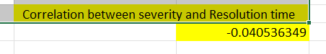



Categorical = “labels” → classify data (who, what, type).

Continuous = “numbers” → measurable data (how many, how long, how much).

The categorical columns are:

* 1. Ticket ID
  2. Severity
  3. Priority
  4. Request Category
  5. Issue Type

Subjective Questions:

1. 1. **Approach with Criteria and Constraints:**

To approach this problem, we need to focus on important investment areas: Hiring more agents, improving training programs, upgrading our ticketing systems.

The main criteria for evaluation are ticket count per agent, avg. resolution time and customer satisfaction rate, as these directly reflect the efficiency and quality of the IT support team. The constraints include the total IT agents (50 agents) and the current ticket metrics, such as a high volume of unassigned and high-priority tickets.

* 1. **References**:

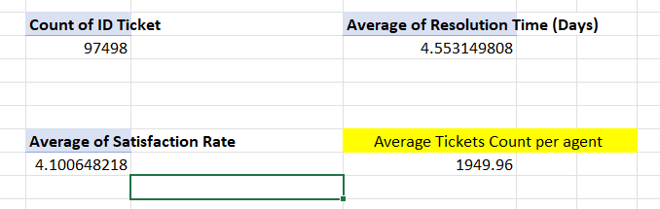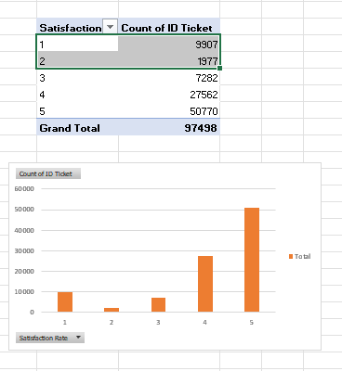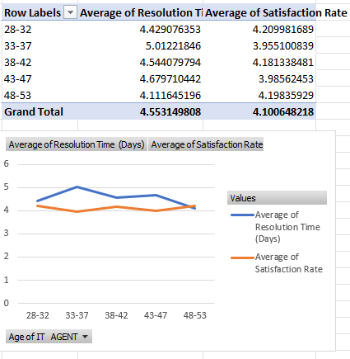

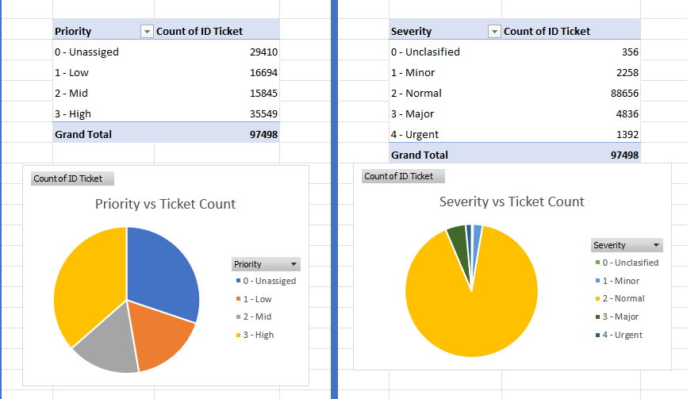

* 1. **Insights Based on the Data:** 
     1. **Hiring is not a priority:** The average number of tickets is around 1950 per agent so it is a manageable workload. The issue is not the number of agents, but rather inefficiencies in the current process.
     2. **Training is a critical need:** While the average satisfaction rate is a solid **4.1**, a significant number of tickets (**12,884**) were rated "1" or "2". This suggests that certain agents or specific types of issues are consistently **underperforming**, indicating a need for targeted training. The data also shows that experienced agents (**age group 48-53**) perform better, suggesting that mentoring or specialized training could improve the performance of less experienced staff.
     3. **Software is outdated**: A key insight from the data is the presence of 29,410 unassigned and 35,549 high-priority tickets. This points to a major failure in assignment process, likely due to inefficient ticket management software. This outdated software prevents tickets from being assigned to the right agent in a timely manner, which directly affects the resolution times and satisfaction.
  2. **Recommendations:**
     1. **Invest in Improving Training Programs:** Develop targeted training programs for IT agents who have lower satisfaction ratings or higher resolution time. Create a special team to handle complex hardware and system issues, as these categories have the longest resolution times.
     2. **Invest in Upgrading Ticket Management Software**: An upgraded system could automate assignment and allotment of priority and its severity, ensuring tickets are routed correctly, which would immediately reduce resolution times and improve overall efficiency.
     3. **No Immediate Hiring**: As the workload is manageable only 1950 tickets per agent is manageable so instead of hiring, we can work on training programs and ticket management software update. The investment would be better spent on improving the skills of the current team and the tools they use to perform their jobs.

1. 1. **Approach with Criteria and Constraints:**

To identify agents requiring additional training, performance was evaluated using two key metrics:

* + 1. Average Satisfaction Rate
    2. Average Resolution Time

Agents were categorized into three bands:

* + 1. High performers – Above average in satisfaction and below average in resolution time.
    2. Mid-range performers – Close to average in both. (slightly above/below).
    3. Low performers – Consistently below average satisfaction and above average res. time.

Mid-range agents were also included for training, because they represent the group with potential for improvement through skills development.

* 1. **References**:

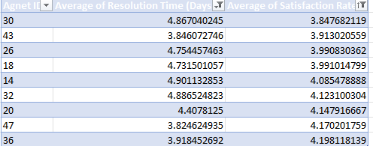 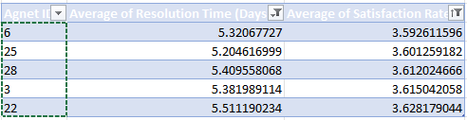

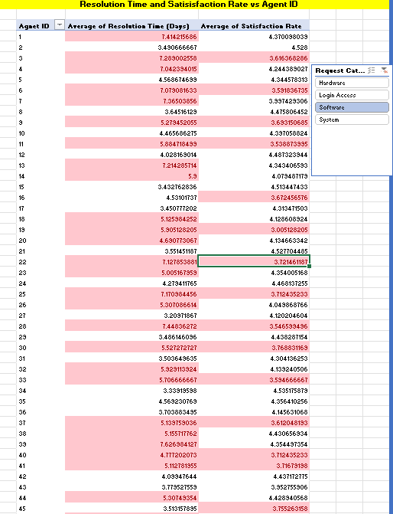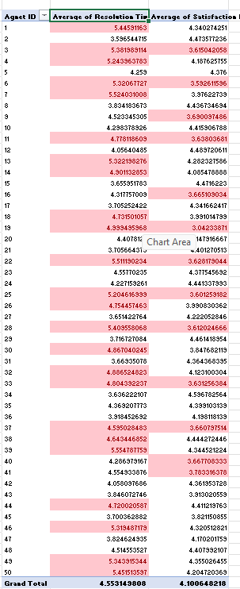

* 1. **Insights Based on the Data:**
     1. The following agents fall into **mid-range performance** group (satisfaction ~3.8–4.2 and resolution time ~4.3–5.2 days):

**Agent IDs:** **30,43,26,18,14,32,20,47,36**

These agents perform around the average but lack consistency. Their cases often fluctuate between efficient handling and delayed resolution, which impacts overall satisfaction.

* + 1. In addition, low-performing agents (below 3.8 satisfaction and above 5.2 days resolution time) were also identified:

**Agent IDs:** **6,25,28,3,22**

* + 1. **Skill Gaps:** The pivot table with slicer shows that some agents **perform well in certain ticket categories but struggle with others.** For example, an agent might be efficient with "Login Access" issues but have long resolution times for "Hardware". This suggests the need for targeted, specialized training.
    2. As noted in the previous analysis, **more experienced agents tend to have better performance**. This suggests that a mentorship program where newer agents are paired with senior will be highly efficient.
  1. **Recommendations:**
     1. Targeted Training for Mid-Range Agents:
        1. Agents **30,43,26,18,14,32,20,47,36** should undergo skill-upgradation sessions focusing on faster troubleshooting and communication.
        2. Training these agents can quickly shift them into the high-performance bracket and uplift team averages.
     2. Comprehensive Training for Low Performers:
        1. Agents **6,25,28,3,22** require in-depth technical and customer service training.
        2. They should also be paired with high-performing mentors (especially from the 48–53 age group) for guided learning.
     3. Mentorship Program:
        1. Assign senior agents with strong records (satisfaction >4.3 and resolution <4.0 days) as mentors.
        2. This will help both mid-range and low performers gain practical insights and develop consistency.
     4. Regular Monitoring:
        1. Track the improvement of identified agents after training using monthly satisfaction and resolution metrics.
        2. If performance remains same, additional one-to-one coaching should be considered.

1. 1. **Approach with Criteria and Constraints:**

To determine if certain **request categories** have longer resolution times, an analysis was performed by creating a pivot table. The main criterion for this analysis was the average Resolution Time (Days) for each category.

* 1. **References**:

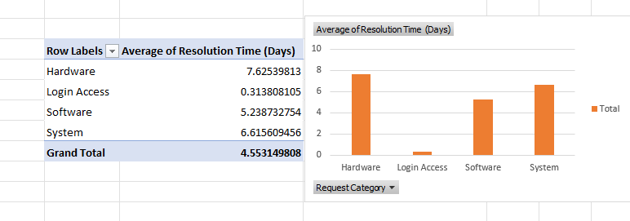

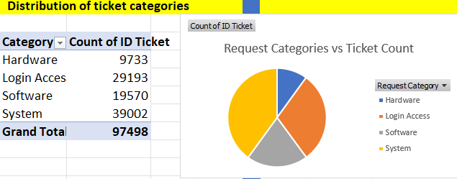

* 1. **Insights Based on the Data:** 
     1. Login Access issues are the quickest to resolve, with an average resolution time of approximately 0.31 days.
     2. Hardware issues consistently have the longest resolution times, taking an average of 7.62 days to resolve.
     3. Software and System issues also have longer resolution times compared to Login Access, indicating they are more complex and require more time to troubleshoot.
     4. Also, an additional information is that system and software issues are very high as compared to hardware

The data confirms that **the type of request is a major factor** in how long it takes to resolve a ticket.

* 1. **Recommendations:**
     1. Form a dedicated team which only handles complex issues like Hardware and System problems. This specialization can lead to a significant reduction in resolution times for these categories.
     2. Develop a knowledge base with troubleshooting guides for common Hardware, Software, and System issues. This would allow agents to resolve tickets more efficiently and early.
     3. Since Login Access issues are frequent and fast to resolve, consider implementing an automated self-service portal to handle these requests. This would free up agents to focus on more complex tickets.

1. 1. **Approach with Criteria and Constraints:**

As there is no given data after the investment. However, we can do analysis based on current data and current situation and will compare then how things will change. For current tools and current situation, we must consider the main criteria for the same:

1. The number of tickets that are unassigned.
2. The number of tickets with a high priority that remains unaddressed.
3. The tickets with urgent or major severity remans unaddressed.
4. The drawbacks in the ticket management process, indicated by the discrepancy between ticket volume and resolution times and satisfaction rate.
   1. **References**:

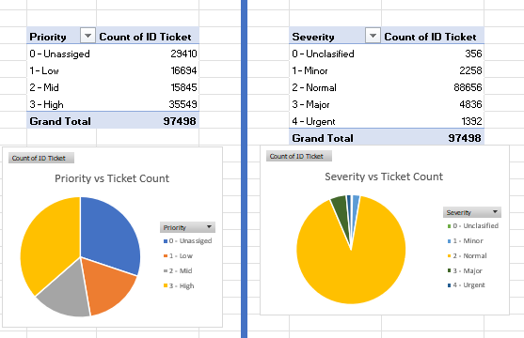

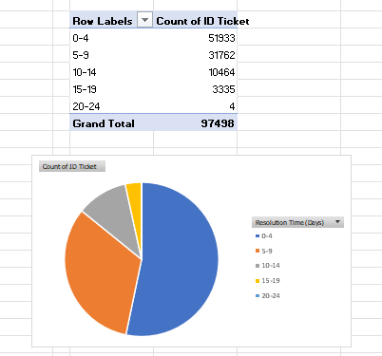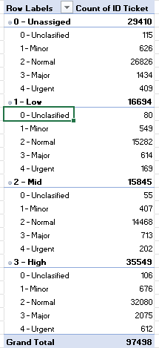

* 1. **Insights Based on the Data:** 
     1. 29,410 tickets are unassigned, while a high volume of tickets (35,549) is marked as High Priority. This is a major insight that directly points to a failure in assignment of priority, which is a core function of software.
     2. This downside contributes to larger resolution times for complex issues, as tickets are not being assigned to the correct agents within time. This negatively impacts customer satisfaction, especially during periods of high-ticket volume.
     3. The data (from Question 10) also shows that the volume of tickets is increasing, particularly in peak months like August, October, and December. The current software unable to scale to handle this increased demand efficiently.
     4. The resolution time 5-14 days combined have 41000+ tickets which make sit total failure of the ticket management system as it is unable to make it assigned properly.
  2. **Recommendations:**
     1. The most impactful investment would be to upgrading the ticket management software. This should be utmost priority as it directly addresses the main cause of the system's inefficiency.
     2. The new software should have improved features for automated ticket assignment. This would ensure that high-priority tickets are immediately assigned to the agents, reducing the number of unassigned tickets and reducing overall resolution times.
     3. A new software solution should include a built-in knowledge base and reporting tools to help agents quickly find solutions and management to track performance and identify future problems.
     4. Design some troubleshooting guides which automatically helps in reducing resolution time.

1. 1. **Approach with Criteria and Constraints:**

To analyse how the IT team's performance has changed over time, a trend analysis was performed using time-series data. The main criteria for this analysis were:

* + 1. Ticket Volume over time
    2. Resolution Time
    3. Satisfaction Rate
  1. **References**:

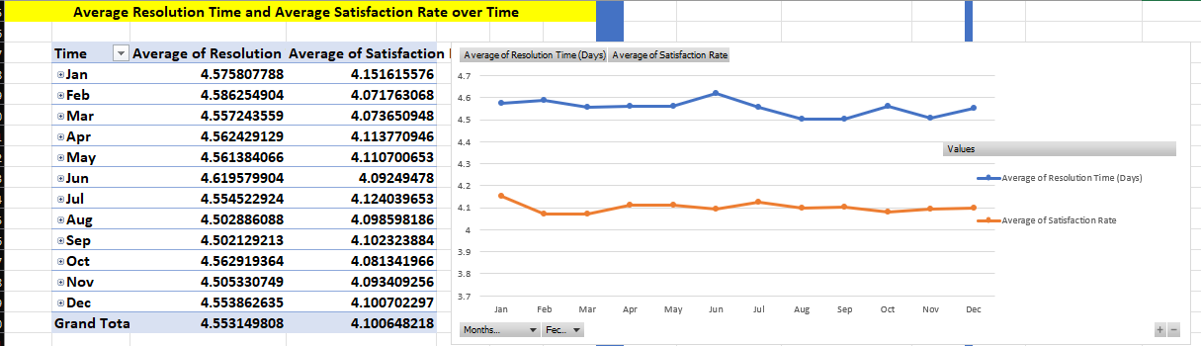

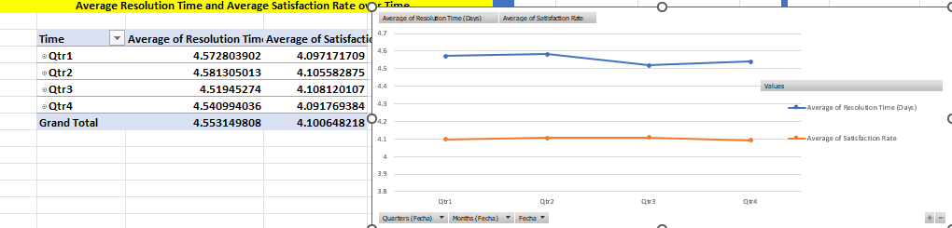

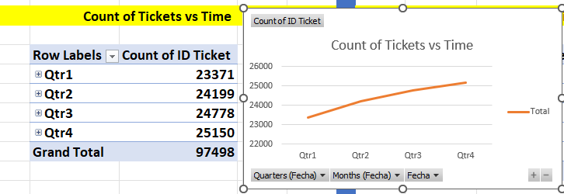

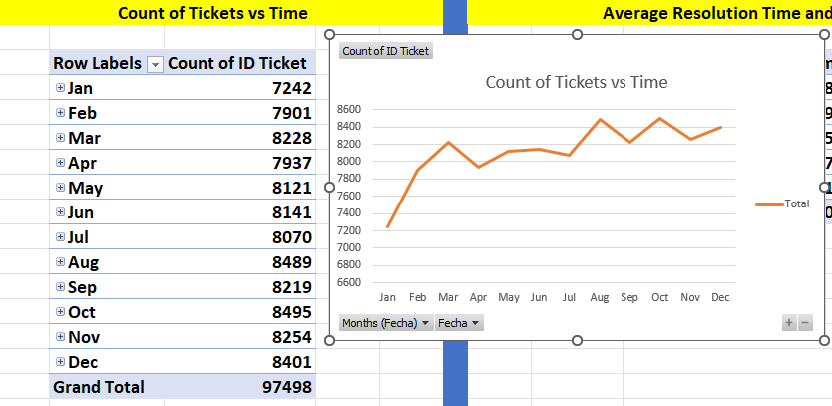

* 1. **Insights Based on the Data:** 
     1. The volume of tickets is increasing over time in a nearly linear fashion, indicating a rising number of user issues.
     2. The data identifies August, October, and December as the peak months for ticket volume, while January has the lowest number of tickets.
     3. There is an inverse relationship between ticket volume and customer satisfaction.
     4. The months with the lowest satisfaction rates, such as February and March, are noted to be periods when the number of tickets increases, causing a "very dip" in satisfaction rate.
  2. **Recommendations:**
     1. To manage the increasing ticket volume, scalable solutions like automation and strategic staffing should be considered.
     2. The team should be prepared for the predictable surge in tickets during peak months to prevent a drop in the satisfaction rate.
     3. A high volume of system and login access tickets (refer Question 3 for category wise distribution of tickets) suggests a need for enhanced system stability and user access protocols. Implementing proactive maintenance could reduce the number of hardware-related tickets, improving overall performance and satisfaction rate

1. 1. **Approach with Criteria and Constraints:**

As there is no data given about before and after but we can use historical data to compare how system works and can predict where improvements are needed. The main criteria for this evaluation are the performance metrics that are directly impacted by technology, such as the number of unassigned tickets and the resolution times for all kind issues. The analysis will use these metrics to find the benefits of a technological investment.

* 1. **References**:

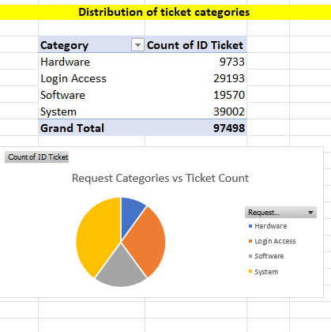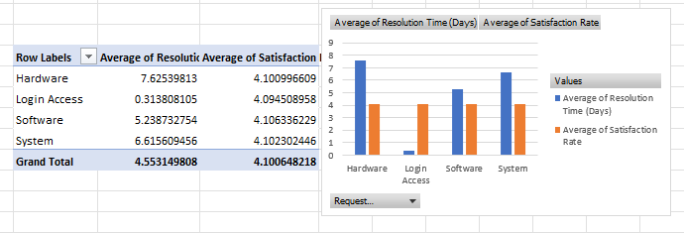

* 1. **Insights Based on the Data:** 
     1. The data reveals a major problem with 29,410 unassigned tickets, even with a high number of 35,549 tickets marked as "High Priority" (Question 4 data reference). This indicates that the current ticket management software is not assigning tickets correctly which directly contributes to delays. An investment in new software with better automation and assigning capabilities would directly help to resolve this issue.
     2. The data shows that tickets related to Hardware (7.62) and System (7.55) issues have the longest resolution times. This suggests that IT agents may lack the important tools or updated hardware to diagnose and resolve these issues. Providing agents with better diagnostic software or more efficient hardware would logically shorten these resolution times.
     3. As highlighted in previous analyses, there is an inverse relationship between ticket volume and satisfaction rates. By improving the efficiency of the software/hardware, results in faster resolutions and higher satisfaction rate.
  2. **Recommendations:**
     1. A new software solution should be implemented to automate the assignment of tickets. This would reduce the number of unassigned tickets and shorten overall resolution times.
     2. To resolve the long resolution times for hardware and system tickets, provide the IT agents with advanced diagnostic tools and updated hardware. This would enable them to troubleshoot and fix complex issues more efficiently.
     3. Create a team specialised in hardware and system issues which can take care of these perfectly.

1. 1. **Approach with Criteria and Constraints:**

The key performance metrics for IT agents were defined as:

* + 1. Average Resolution Time– how quickly issues are resolved.
    2. Average Satisfaction Score– customer satisfaction with the resolution.

Using these, agents were divided into three performance bands:

* + 1. High Performers – Above team average in satisfaction (>4.1) and below team average in resolution time (<4.55 days).
    2. Mid-Range Performers – Around the team average (satisfaction between 3.8–4.2 and resolution time between 4.3–5.2 days).
    3. Low Performers – Below 3.8 in satisfaction and above 5.5 days in resolution time.
  1. **References**:

 

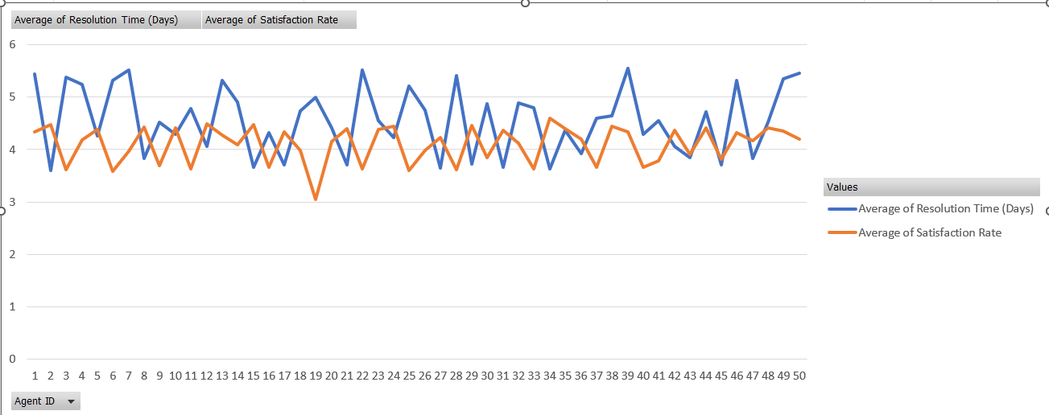

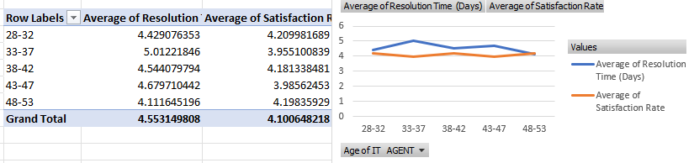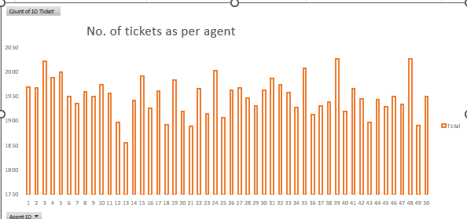

* 1. **Insights Based on the Data:** 
     1. High Performers :

Agents 2,8,15,21,29,34– consistently high satisfaction (>=4.4) and quick resolutions (<=3.9 days).

These agents can act as mentors.

* + 1. Mid-Range Performers (Require Training):

Agents 30,43,26,18,14,32,20,47 – satisfaction near average (3.8–4.2) and resolution times slightly higher than average (~4.3–5.2 days).

They show potential but need targeted training to stabilize their performance.

* + 1. Low Performers (**Termination Risk**):

Agents 22,28 – consistently poor satisfaction scores (<3.8) and very long resolution times (>5.5 days).

These agents negatively impact overall customer experience and team performance.

* 1. **Recommendations:**
     1. Training for Mid-Range Agents
        1. Agents 30,43,26,18,14,32,20,47 should be enrolled in skill development programs focusing on troubleshooting efficiency and communication.
        2. Pair them with mentors (e.g 2,8,15,21,29,34).
     2. Retention & Mentorship Program
        1. Recognize and retain top-performing agents (2,8,15, 21,29,34).
        2. Formalize a mentorship structure where these agents guide weaker colleagues.
     3. Performance Improvement Plan:
        1. Place low-performing agents (22,28) under a performance improvement plan with clear targets.
        2. If no significant progress is observed, **termination should be considered to maintain service standards.**
     4. Continuous Monitoring
        1. Monthly tracking of each agent’s average resolution time, average satisfaction rate to identify early signs of performance dips.
        2. Use dashboards with alerts for satisfaction <3.8 or resolution >5.5 days.
  2. **Approach with Criteria and Constraints:**

To determine how employee demographics, specifically age, impact satisfaction and ticket outcomes, a segmented analysis was performed using pivot tables. Also, as there is no mention of department or seniority of role, we can assume the age as a factor for seniority and do the analysis based on the same. The primary criteria for this evaluation were:

* + 1. Average Resolution Time (Days)
    2. Average Satisfaction Rate
  1. **References**:



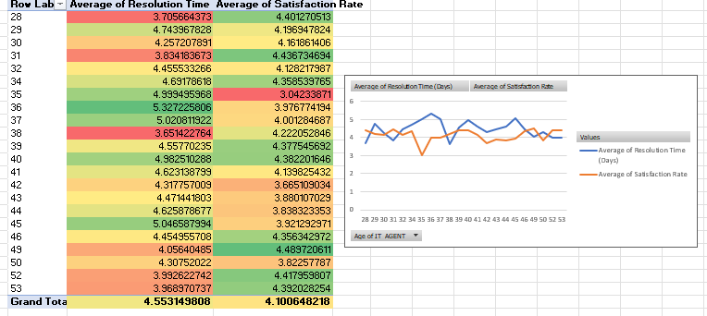

* 1. **Insights Based on the Data:** 
     1. The data shows a strong relation between age and performance. The most experienced agents (48-53 age group) have a higher avg. satisfaction rate and a lower average resolution time as compared to the overall average. This group is identified as the best performing demographic.
     2. The 33-37 age group has the longest resolution times, gives this group could benefit the most from additional training.
     3. Other age groups such as 28-32 and 38-42 also perform well, but the oldest group (48-52) consistently outperforms them.
     4. Also, if we check on agents of every age, we had findings like:
        1. Agents with age 36, 38 and 45 are less performing as for resolution time.
        2. In satisfaction rate agents with age of 35 are worst performing.
  2. **Recommendations:**
     1. Use the knowledge and experience of the top-performing 48-53 age group by establishing a mentorship program for low performing age-groups. This allows low performing groups to excel in their field.
     2. Focus training programs specifically on the 33-37 age group to improve their resolution times and boost their satisfaction rate.
     3. Encourage experienced agents to create a knowledge base or troubleshooting guides to share their expertise across the team, ensuring that high performance is not dependent on a few agents.

1. 1. **Approach with Criteria and Constraints:**

To identify trends in IT Agents’ operations, a time-series analysis was conducted using Fecha (Date) to aggregate data monthly. The main criteria for this analysis were:

* + 1. Ticket Volume
    2. Satisfaction Rate

The analysis aimed to identify periods of high and low activity to determine a trend. The constraint is the reliance on the available data, which provides a timeline for tickets but not specifically "peak and off-peak hours" in a day. Therefore, this analysis was conducted on a monthly basis.

* 1. **References**:

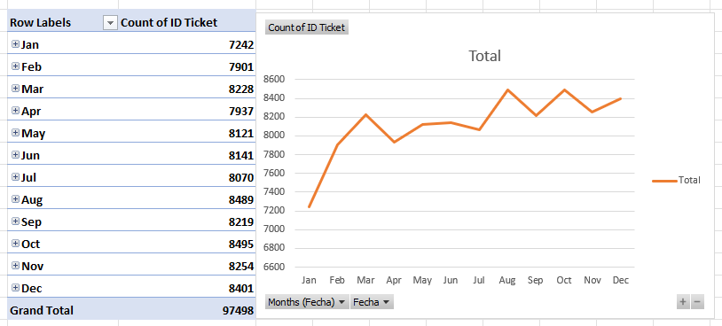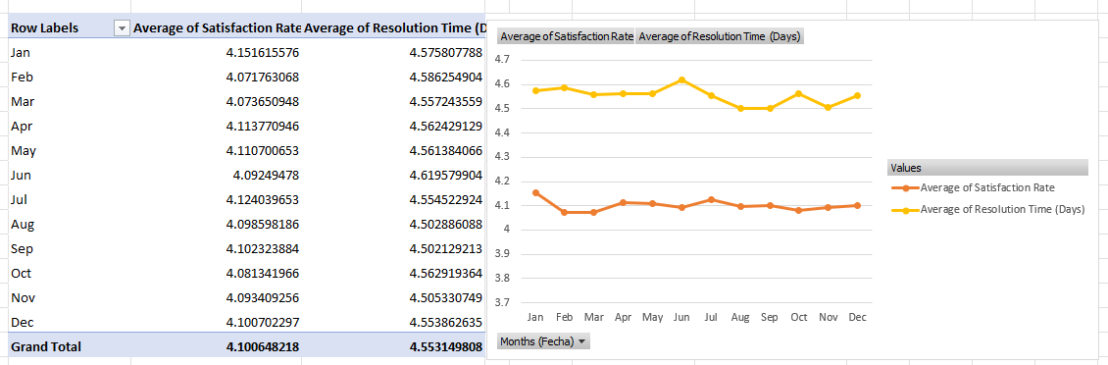

* 1. **Insights Based on the Data:** 
     1. The data identifies **August, October, and December** as the peak months for ticket volume. This suggests a seasonal spike in IT requests, possibly related to business cycles or specific projects.
     2. January is identified as a stable month, with the lowest number of tickets.
     3. Inverse Relationship: A significant insight is the inverse relationship between ticket volume and customer satisfaction. The months with the highest ticket volume correlate with a noticeable drop in the satisfaction rate. Conversely, the month with the lowest ticket volume, January, has the highest satisfaction rate. This suggests that t
  2. **Recommendations:**
     1. To address the predictable spike in tickets during peak months, the team should either increase staffing or optimize agent schedules to ensure better results. This could involve hiring temporary staff or adjusting shifts to handle the increased workload.
     2. The off-peak months, like January, can be used for proactive tasks such as system maintenance, software upgrades, and specialized agent training.
     3. The current software may not be able to scale efficiently to handle the high-volume periods. An investment in a more robust ticket management system with automation could help the team manage the increased workload without lowering satisfaction rate.

The dashboard should be built around the following charts to provide a holistic view of performance:

* + 1. Ticket Volume Over Time: A line chart showing the total number of tickets submitted each month.
    2. Tickets by Request Category: A bar chart illustrating the distribution of tickets across different request types (e.g., Login Access, Hardware, Software).
    3. Satisfaction Rate Over Time: A line chart that tracks the average satisfaction score each month.
    4. Average Resolution Time by Category: A bar chart showing the average time to resolve tickets for each request category.
    5. Satisfaction Rate by Age Group: A bar chart that shows the average satisfaction rate for different age groups of agents.
    6. Tickets by Severity and Priority: Bar charts showing the distribution of tickets by severity (e.g., Minor, Major) and priority (e.g., Low, High).
    7. Distribution of Satisfaction Scores and Resolution Times: Histograms or bar charts that show the frequency of each satisfaction score and the spread of resolution times

To allow for interactive analysis, the dashboard should include **slicers** for Year, Priority, Severity, Issue Type, and Request Category.

DashBoard

